Assignment -4
Python Programming

Assignment Date | 28 October 2022
Student Name | P.S.P.Bharathi
Student Roll Number | 953719104013
Maximum Marks | 2 Marks

Question-1:
Download the dataset
Output:
Download the dataset from
https://www.kaggle.com/code/kredy10/simple-lstm-for-text-classification/data
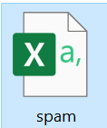

Question-2:
Import required library
Output:
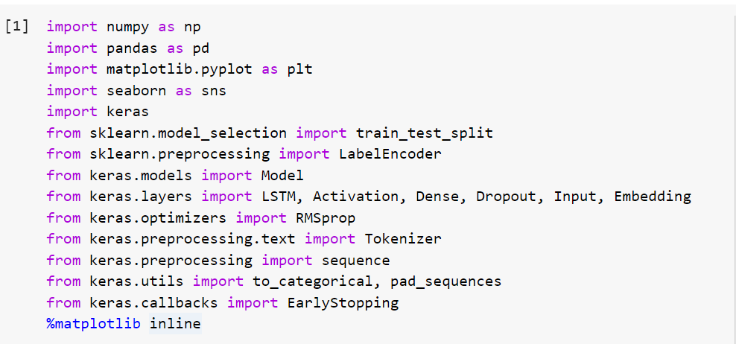

Question 3:
Read dataset and do pre-processing
Output:
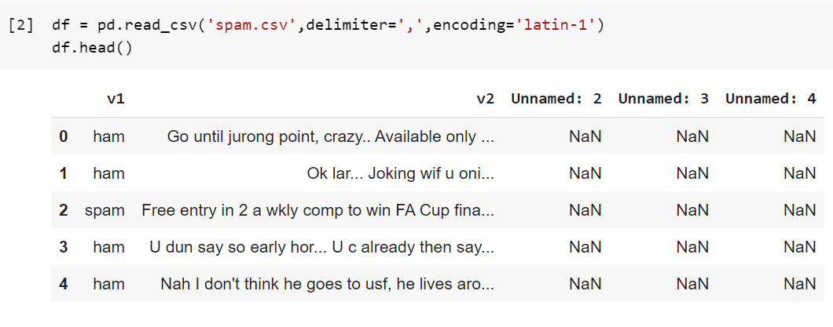
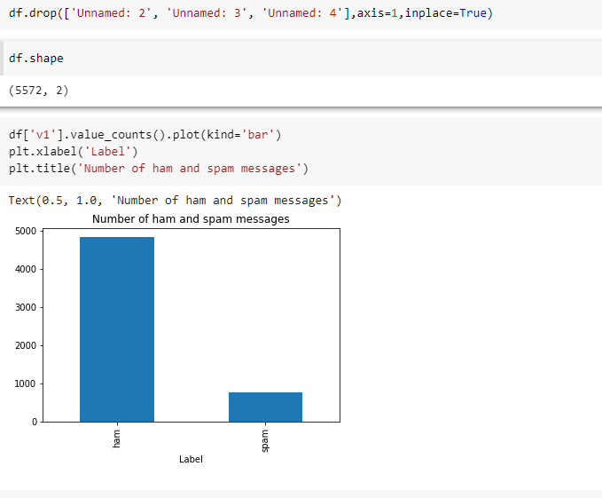
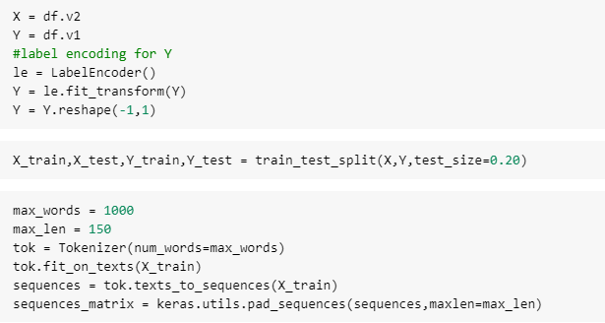

Question 4:
Create Model
Output:
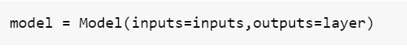

Question 5:
Add Layers (LSTM, Dense-(Hidden Layers), Output)
Output:
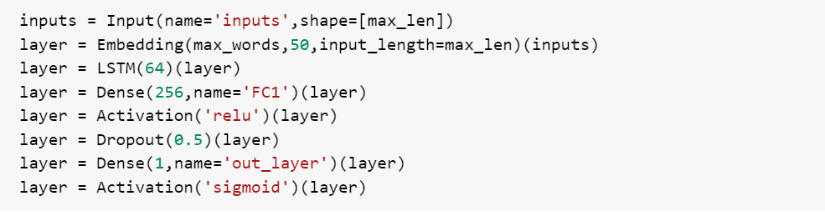
Question 6:
Compile the Model
Output:
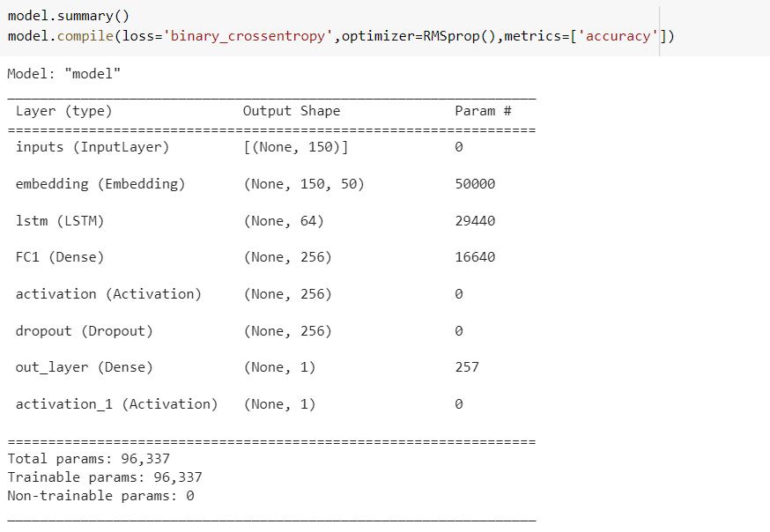

Question 7:
Fit the Model
Output:
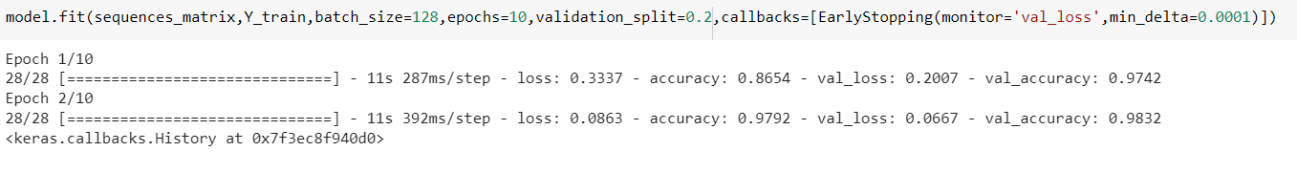
Question 8:
Save The Model
Output:

Question 9:
Test The Model
Output:
